
FOR IMMEDIATE RELEASE:
June 30, 2017
CONTACT:
Dorsey Hager
Executive Secretary-Treasurer at Columbus/Central Ohio Building & Construction Trades Council
(614) 221-7171
columbusbuildingtrades@gmail.com
Columbus Building and Construction Trades Council Helps Put Central Ohioans Back to Work
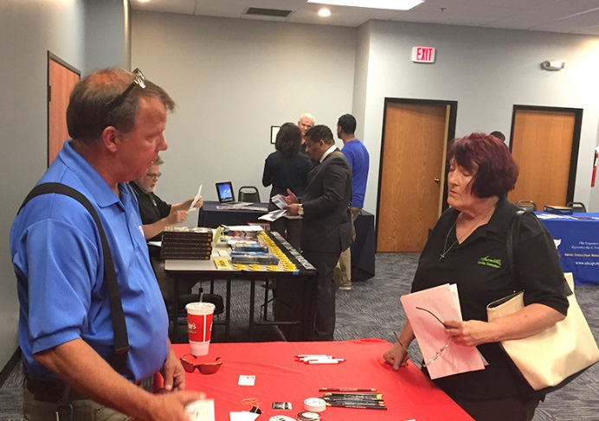
June 30, 2017, Columbus – More than 100 people attended the Columbus/Central Ohio Building and Construction Trades Council free job fair on June 29. Dorsey Hager, the Council’s Executive Secretary/Treasurer, estimated that 90% of attendees were veterans.
“Franklin County has 68,000 military veterans,” said Hager. “These men and women are hard workers with great training. It’s a great match.”
Hager worked with Franklin County Recorder Danny O’Connor to host the event. "I truly appreciate the efforts of Recorder Danny O'Connor and his office partnering with the Building Trades to help put Vets on a ‘path to the middle class,’” said Hager. “His staff and the staff at our event host IBEW 683 worked hard to make the event a success."
A representative from the Bricklayers and Allied Craftworkers discusses job opportunities with a job fair attendee.
Representatives from 15 local construction crafts were on hand, recruiting job seekers into their apprenticeship programs.
Rob Gartner, Training Coordinator of the Columbus Sheet Metal Workers, was very pleased with the turnout. “This job fair gave me the opportunity to spend quality time with folks who were genuinely interested in our program,” he said. Gartner will follow up with seven applicants from the event to help them take the next steps.
“There are jobs right here in Columbus that pay good money and offer great benefits,” Hager said. “We need to get those jobs filled in order for Central Ohio to keep growing.”
###
The Columbus/Central Ohio Building and Construction Trades Council represents more than 18,000 workers from 19 affiliated Local unions and District Councils. The organization works to harmoniously promote the region’s construction trades, to protect the interest of the union construction industry, and to advocate for a healthy labor-management relationship between employers and employees in the building and construction industry.

